DAG

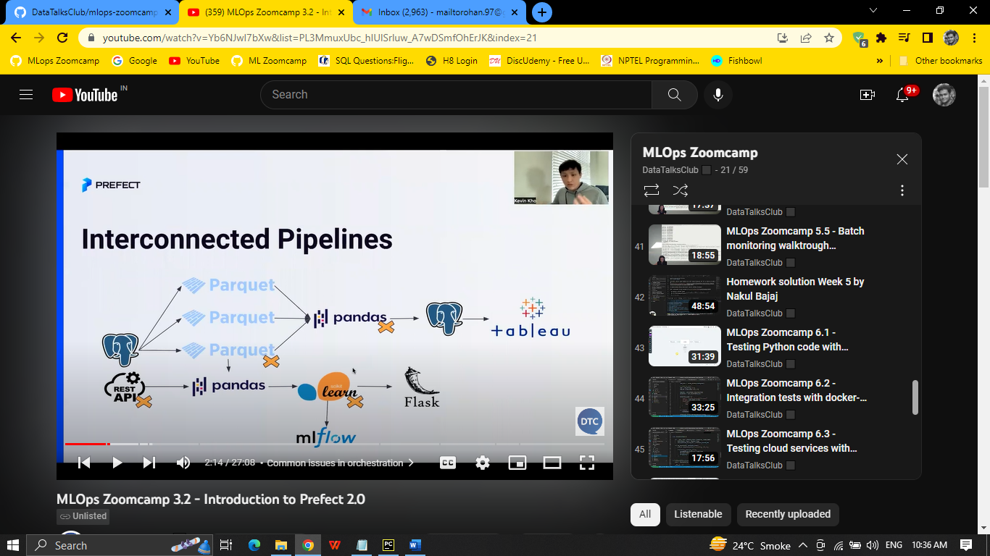

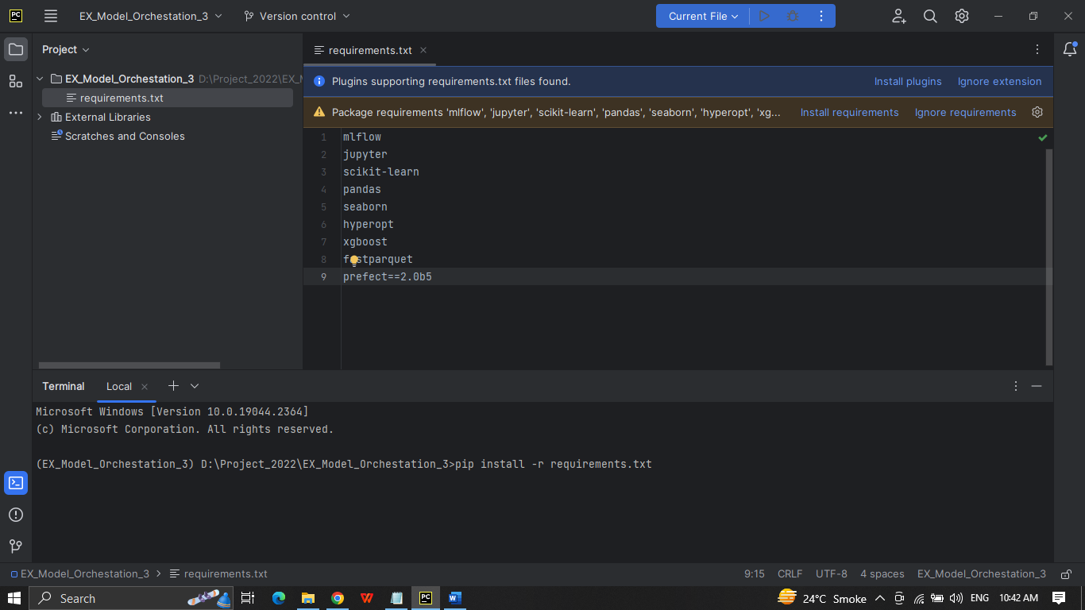

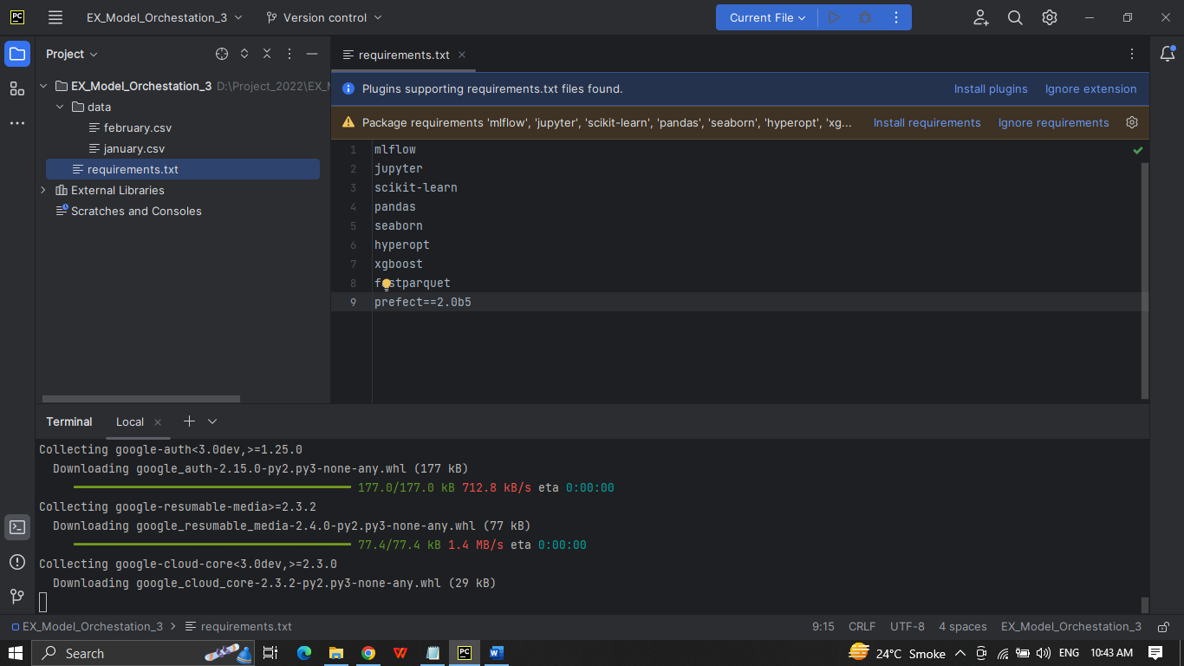

After doing pip install -r requirements.txt

Crate a new python file model_training.py which will contain all the code of module 2 of duration prediction.ipynb with modification

Next create a new script prefect_flow.py and copy the content of model_training.py

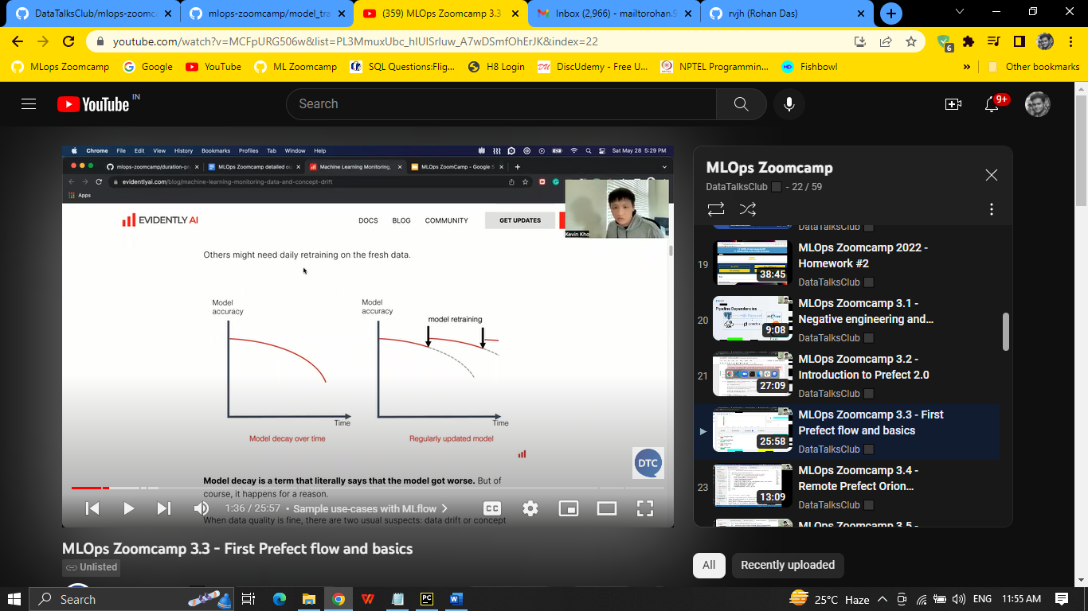

Here the main thing is running as a flow

Copy the path to main, import prefect flow. Comment the search best model as we only work with one model this time and wrap as @flow to get more logs insight

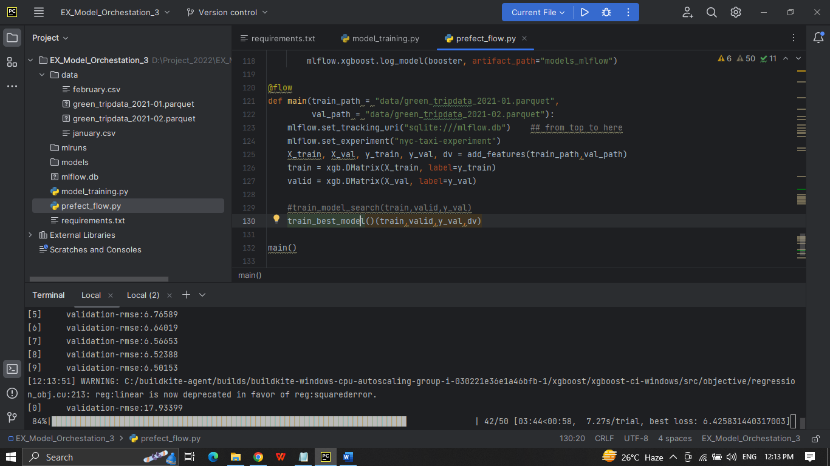

Once done we will get : Finished in state Completed()

Here once you declare anything as a task you have to call the .result() in main fun like

@task

add_features()

X_train, X_val, y_train, y_val, dv = add_features(train_path,val_path).result()

When done get confirmation: Finished in state Completed()

So whenever any function throws an error @ task will return that that function execution has failed or not

We can also tract using prefect orion start to see the experiments in ui

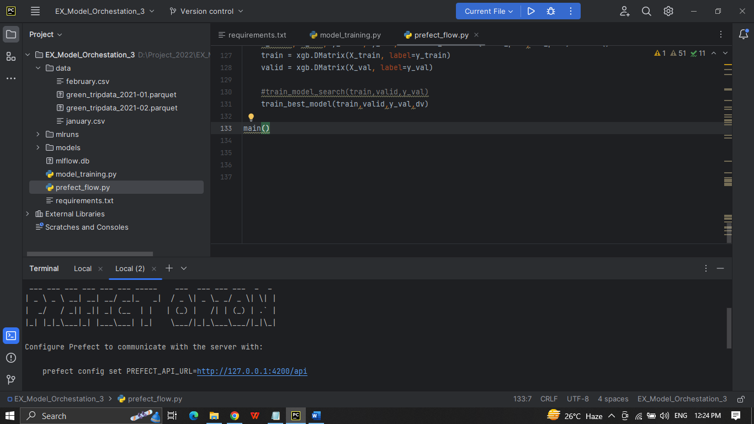

<http://127.0.0.1:4200>

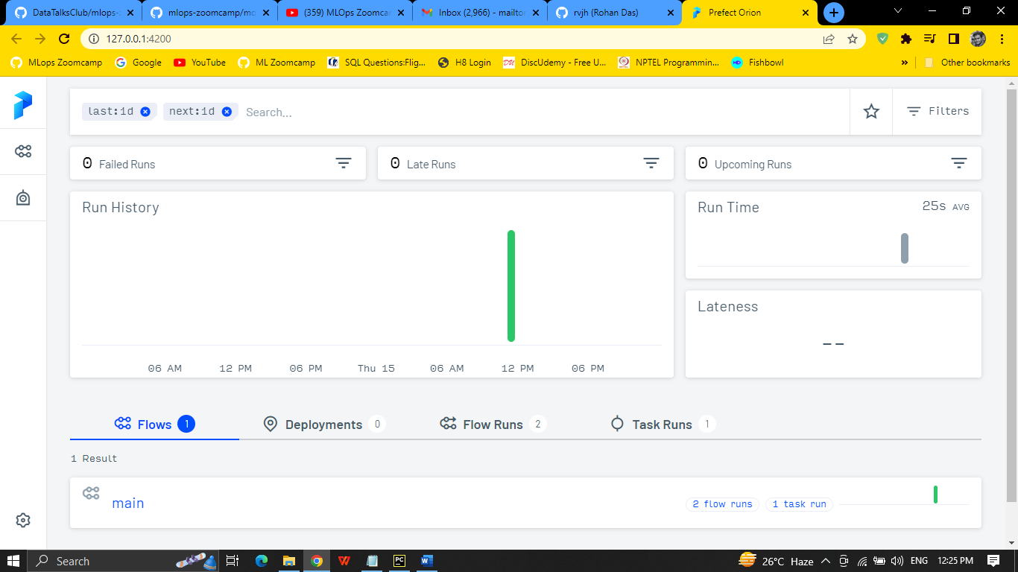

Again run the script

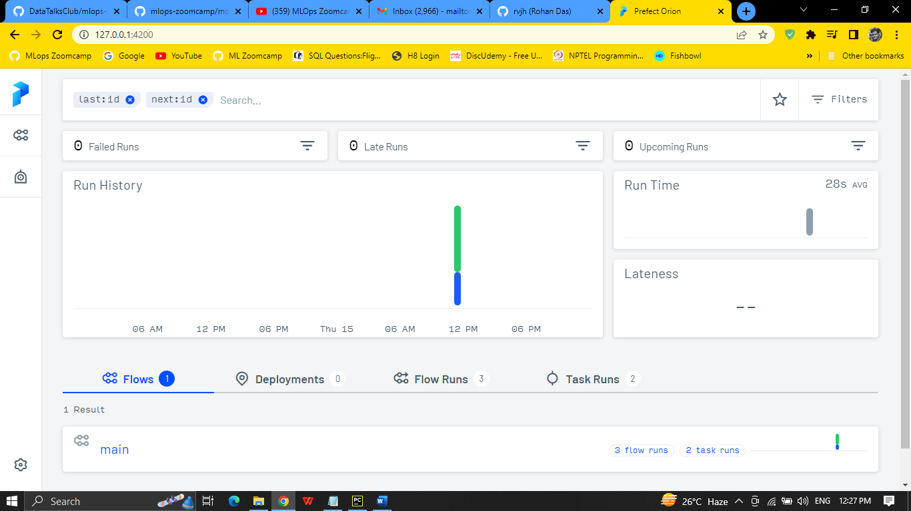

How many runs

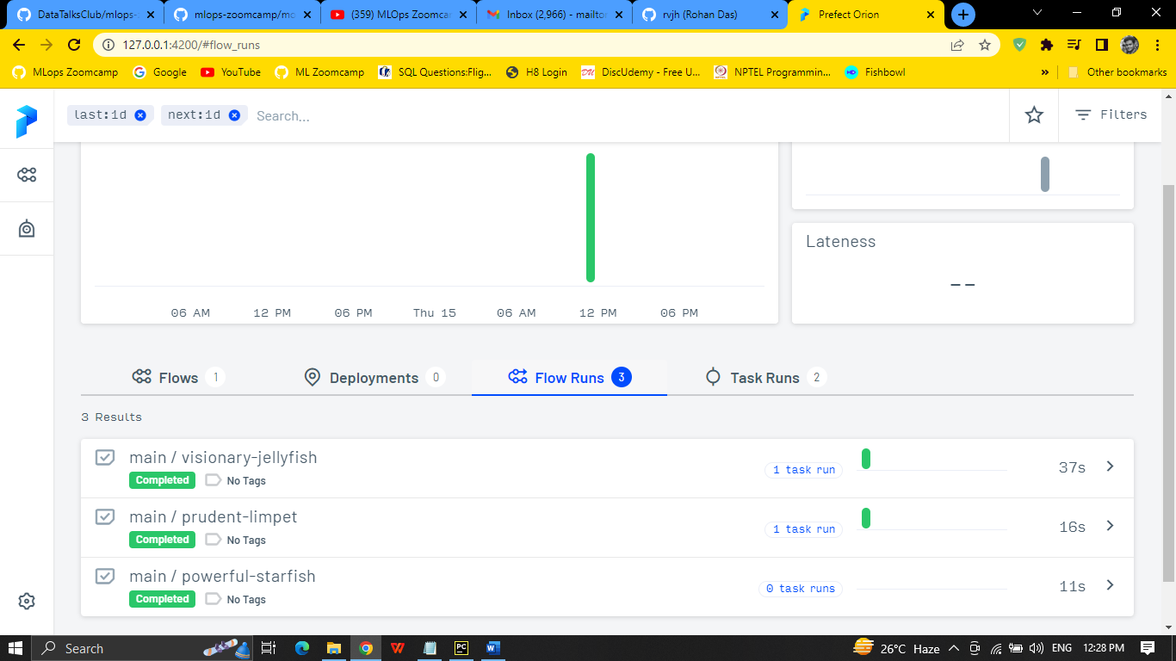

Now uncomment train_model_search

@flow(task_runner=SequentialTaskRunner()) for main function

For sequene of work

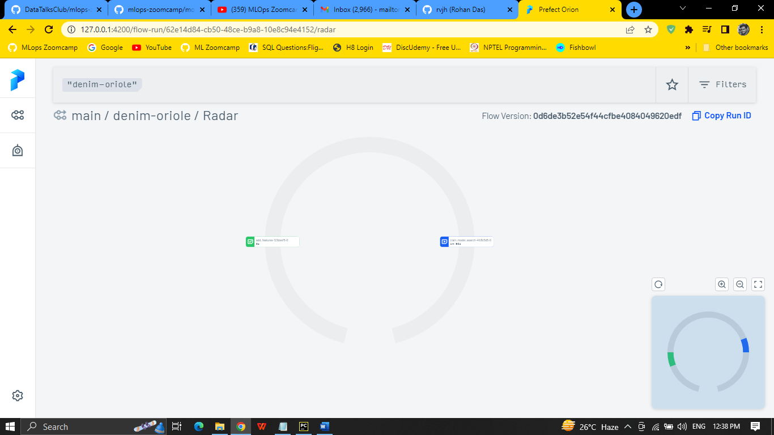

Now change in

X_train = read_dataframe(train_path)  
X_val = read_dataframe(val_path)  
X_train, X_val, y_train, y_val, dv = add_features(X_train,X_val).result()

And

def add_features(df_train,df_val):  
 #df_train = read_dataframe(train_path)  
 #df_val = read_dataframe(val_path) => to see more on rader plot

also it keeps track for invalid parameters as well

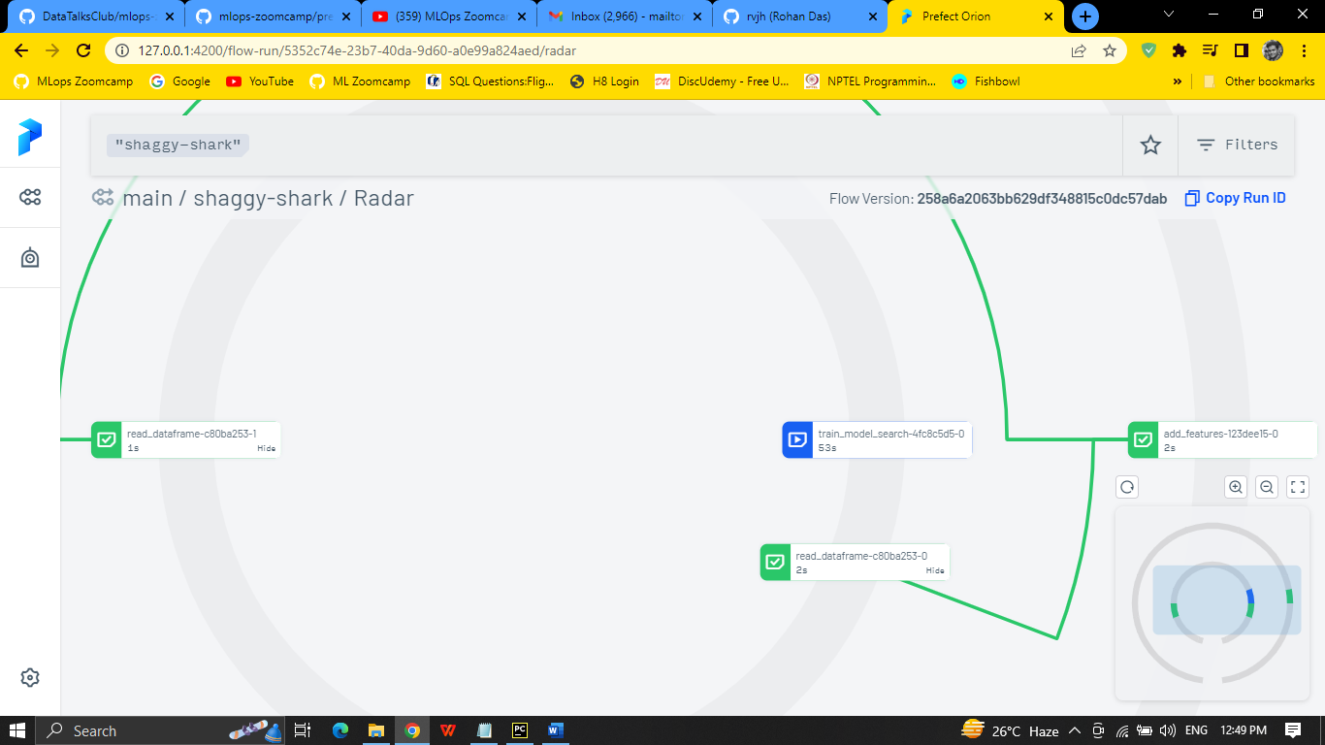

Hosting Prefect Orion in AWS Cloud

IN aws create an instance

Adding the security groups

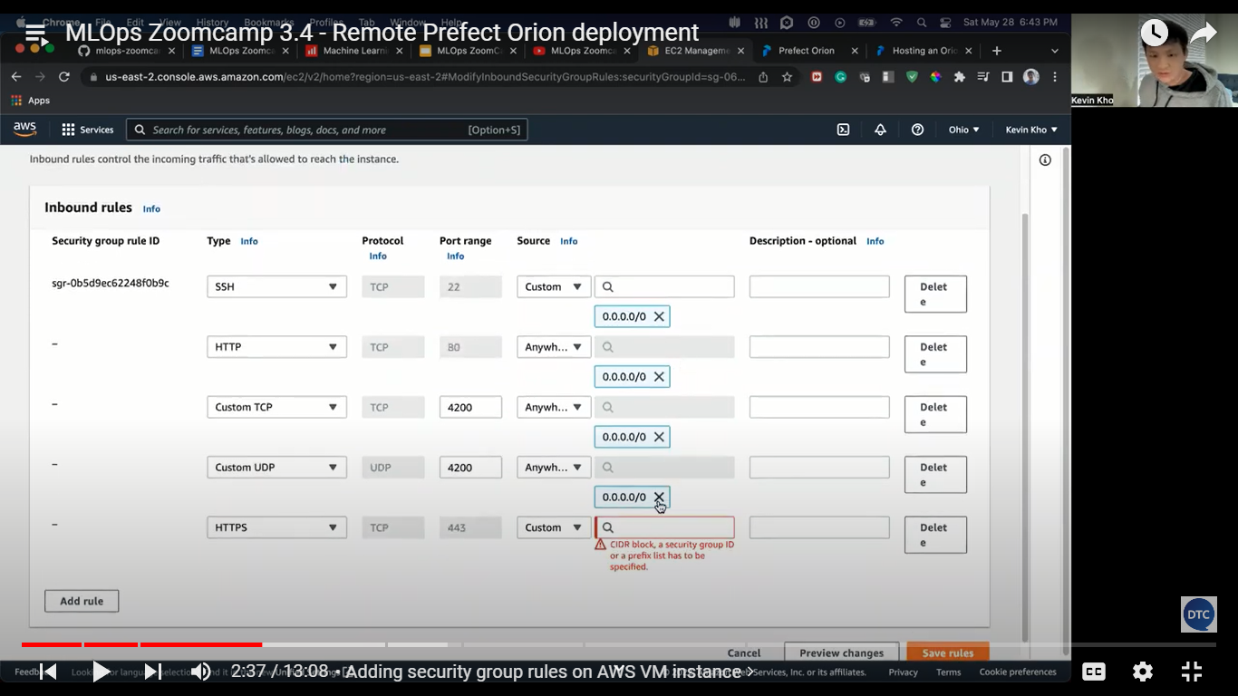

Copy the ipv4

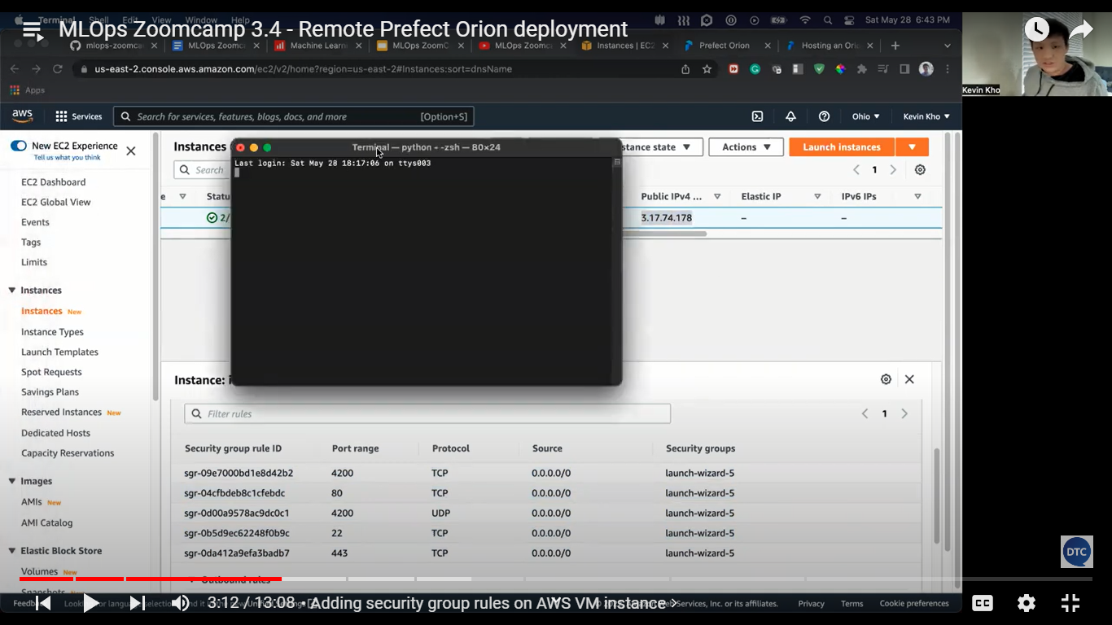

Connect with vm using .pem or .ppk

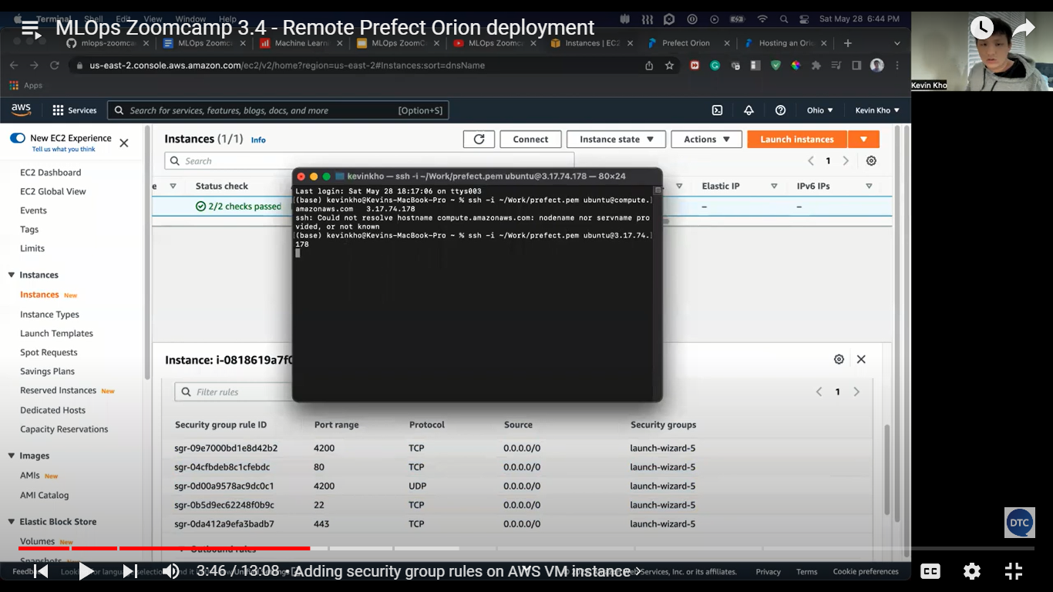

Install the required library like prefect

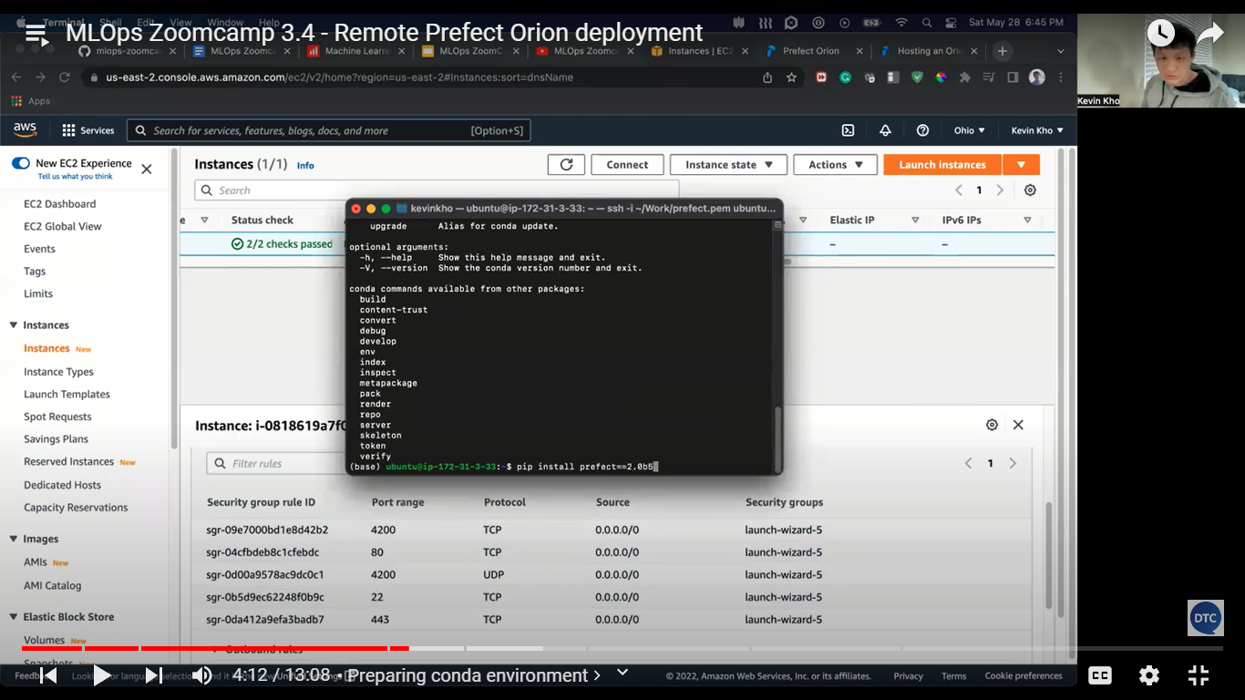

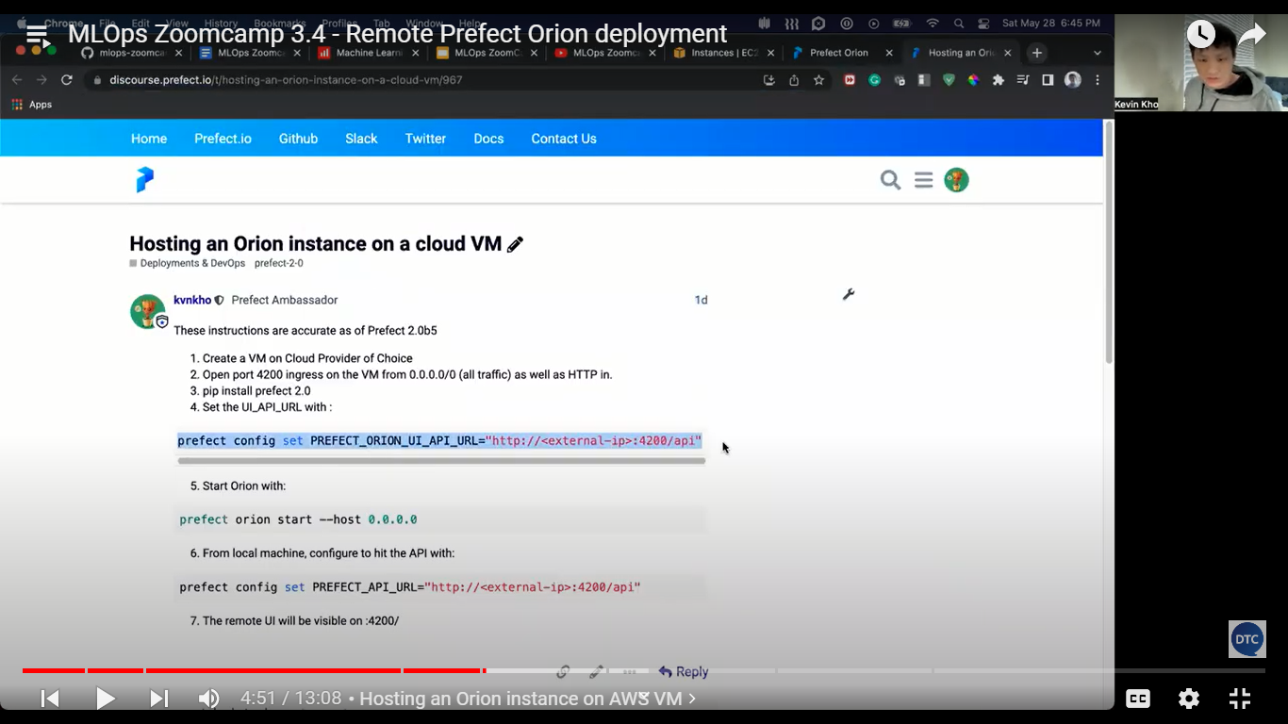

Change the external ip

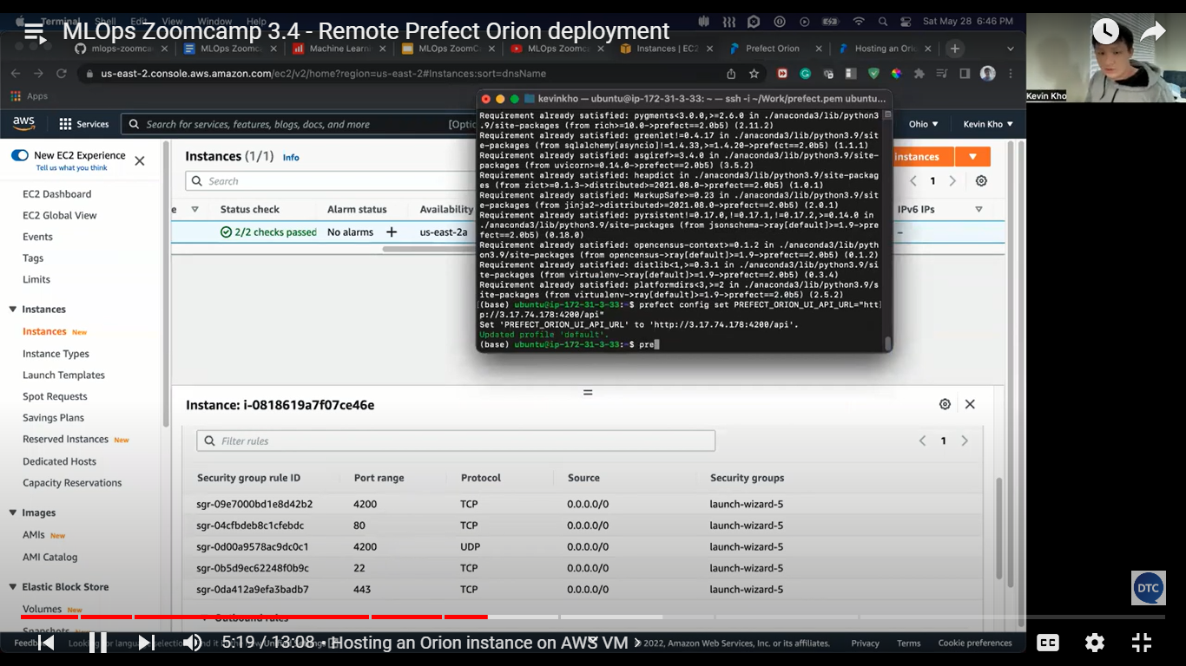

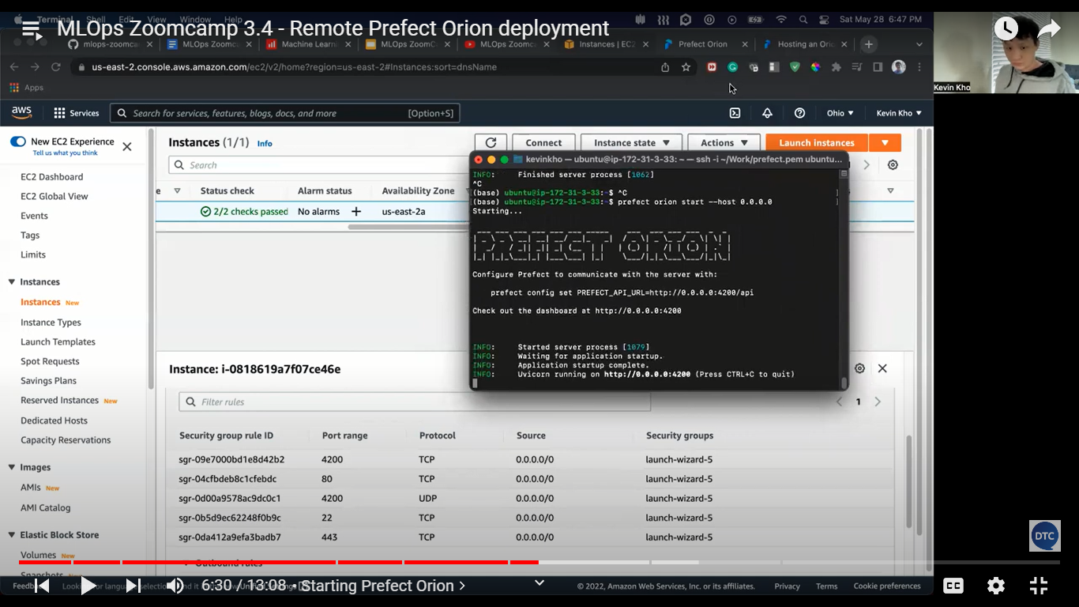

Public ip : 4200

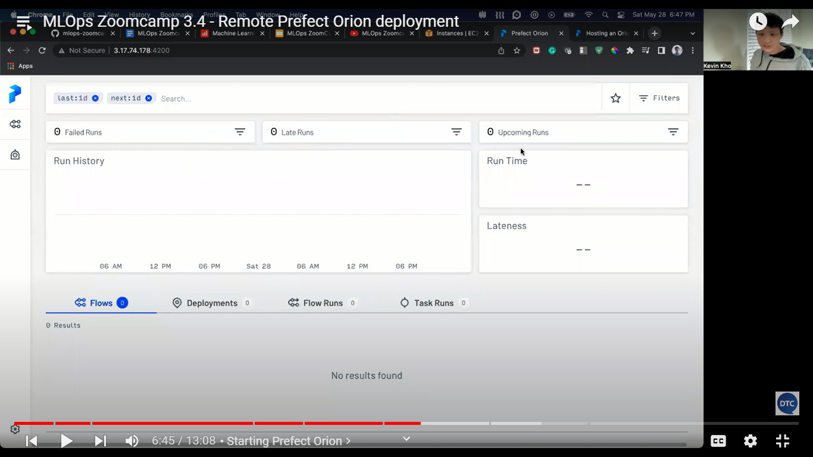

In pycharm change the exter ip change

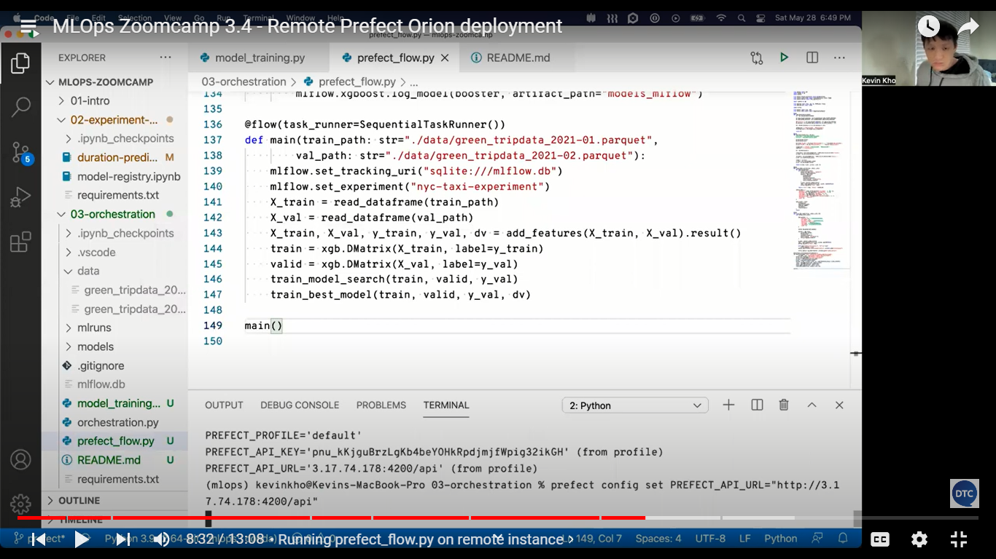

Now run

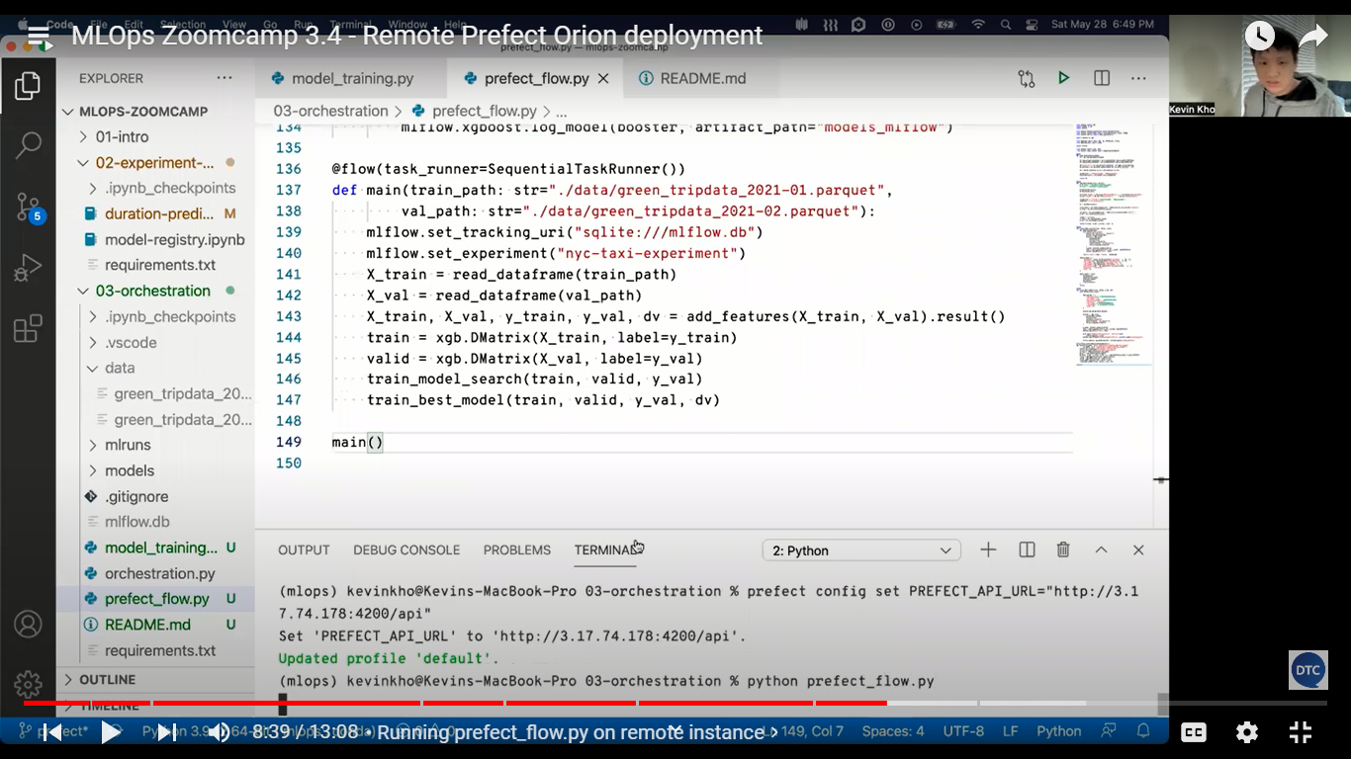 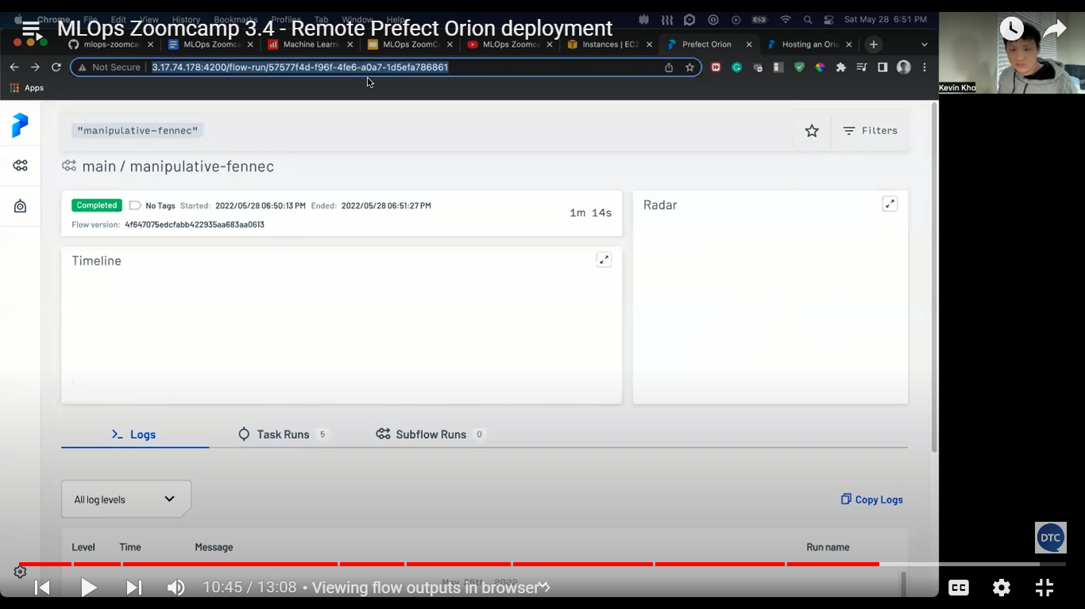

Prefect flow on AWS

Storage

Prefect storage ls -> currently we don’t have any storage

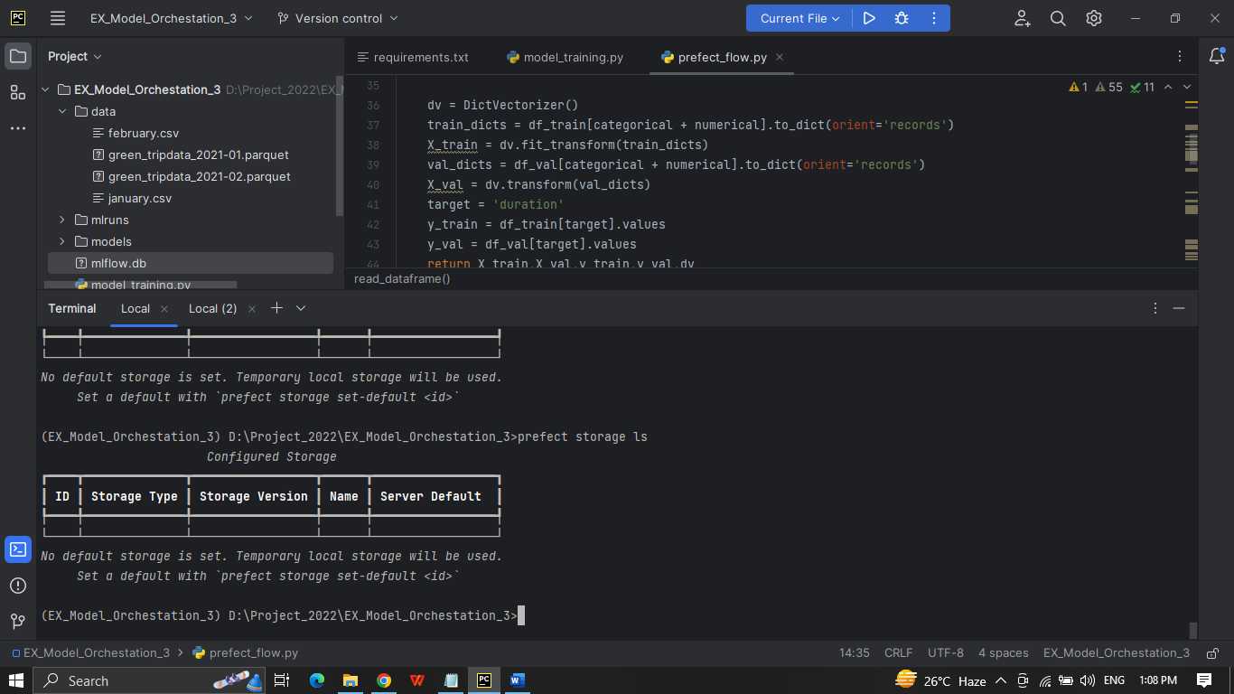

We can crete by prefect storage create

You can select option to get storage

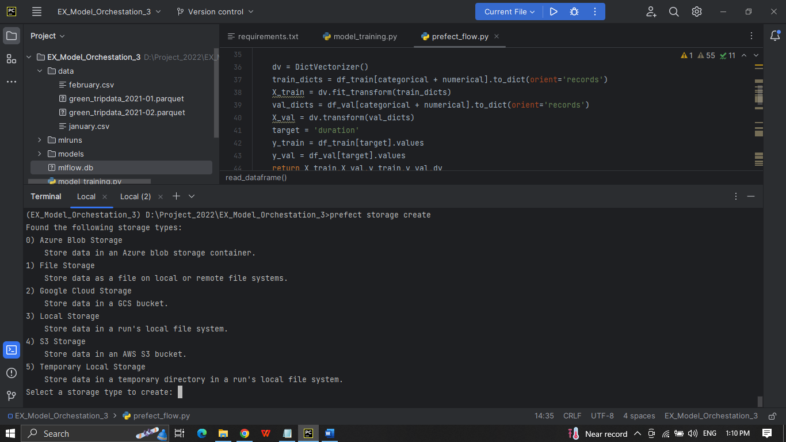

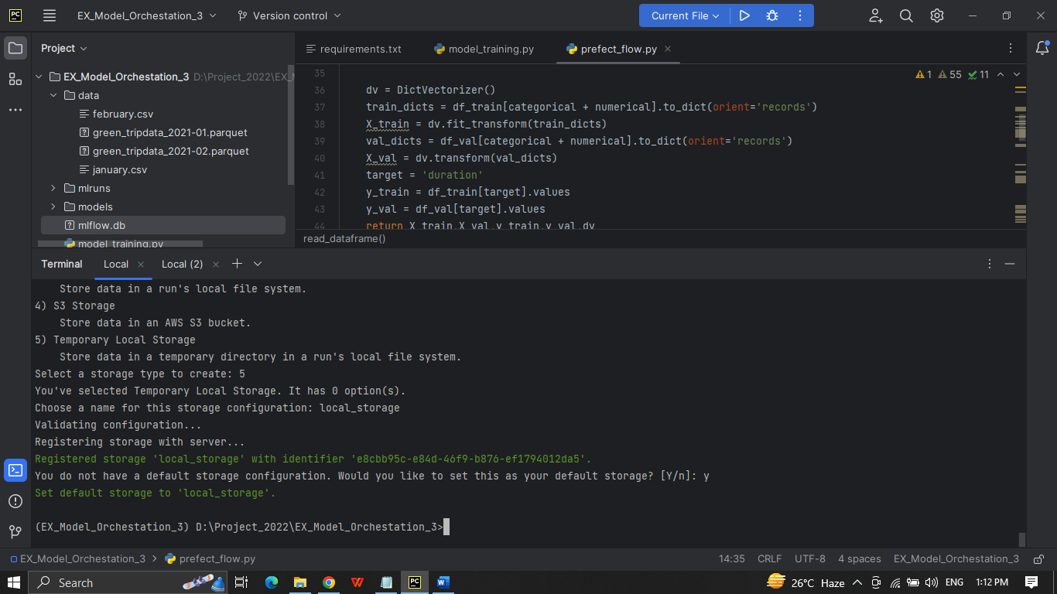

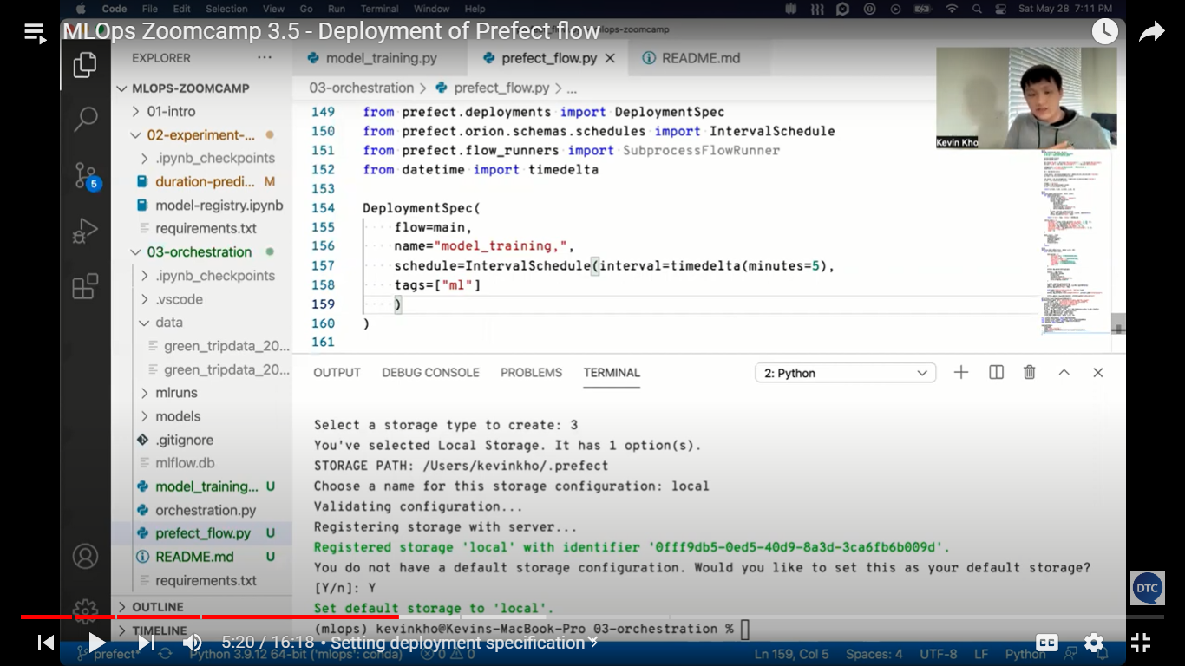

Create another script And run the script

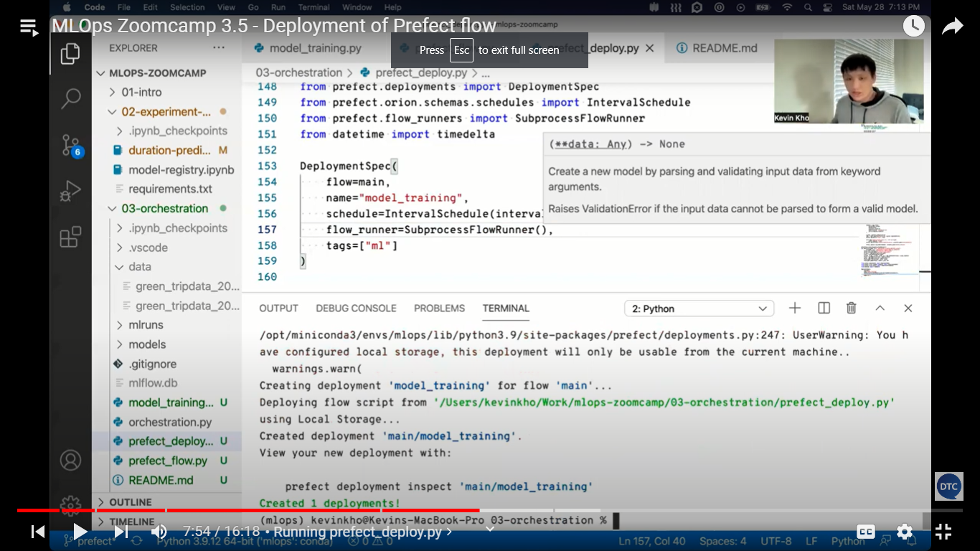

To run on local, docker etc

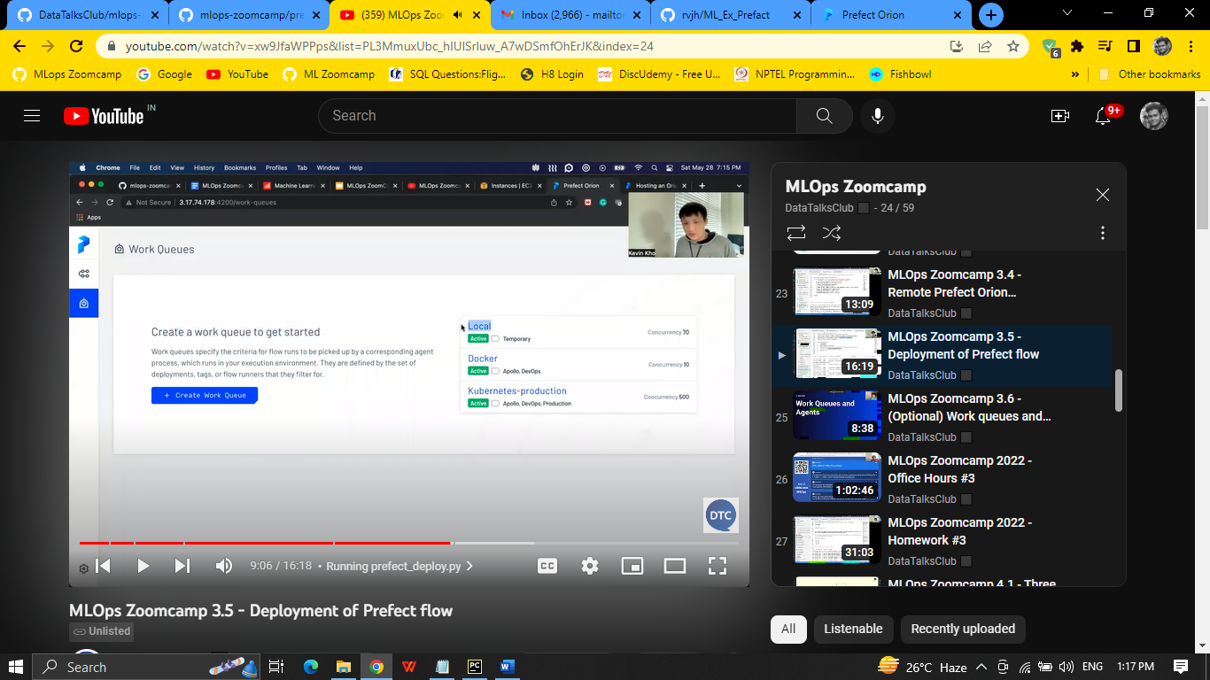

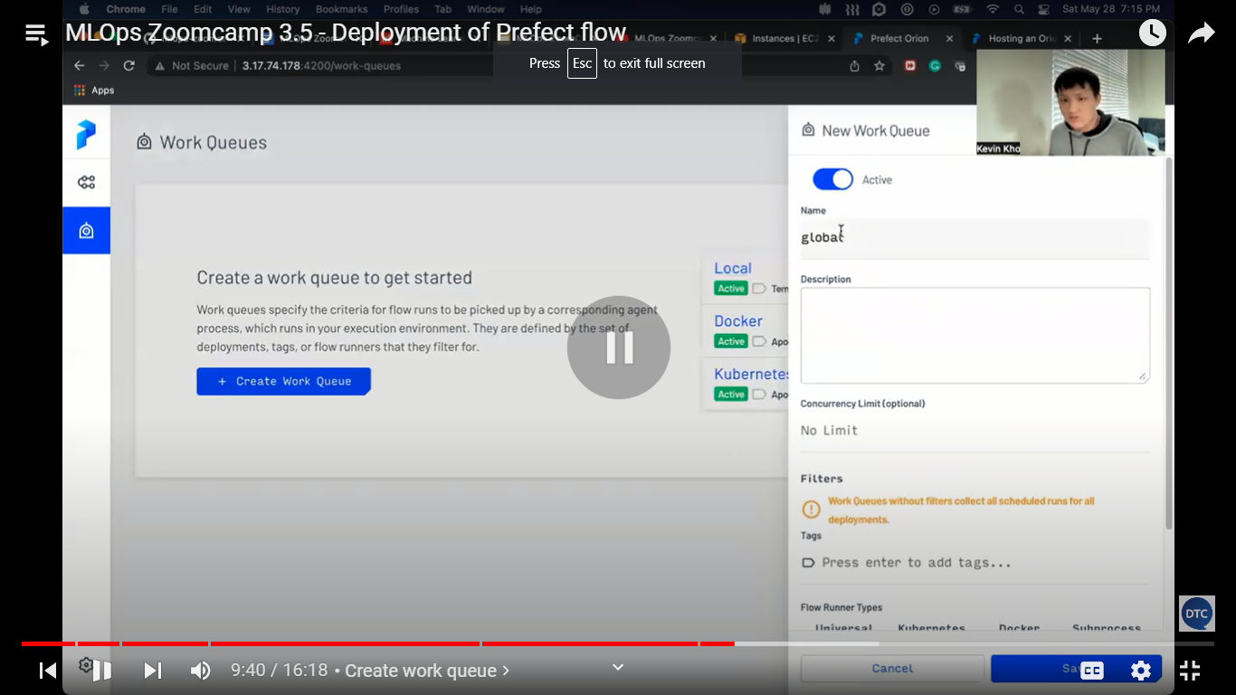

Copu workqueur id

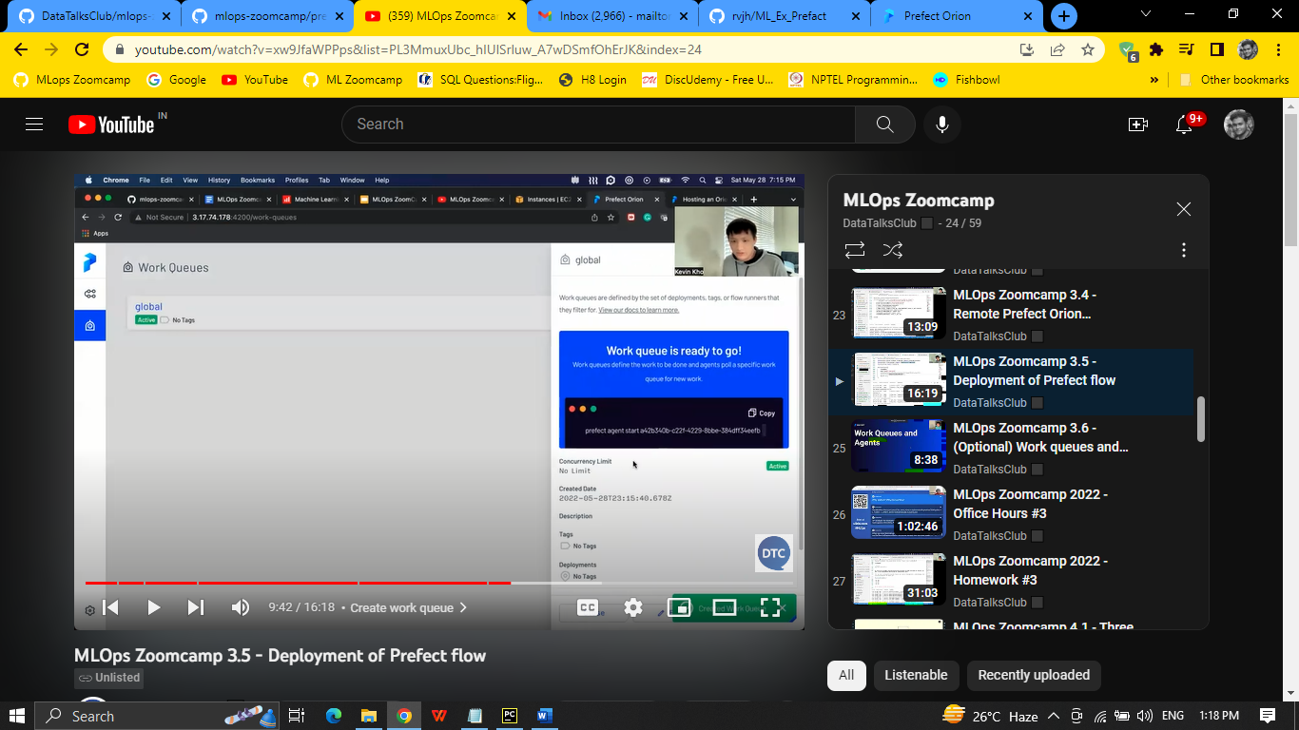

To start the agent

